

EVEREST ENGINEERING COLLEGE
(AFFILIATED TO POKHARA UNIVERSITY

A Minor Project Report
On
STOCK MARKET FORECASTING USING LSTM AND ARIMA MODEL

Submitted By:
Anish Acharya [21075396]
Bhuwan Prasad Joshi [21075406]
Chetan Babu Bhat [21075409]
Pradeept Jarur Shahi [21075421]

Submitted To:
Department of Computer and IT Engineering
Everest Engineering College
Sanepa-2, Lalitpur

Feb 25, 2025

ACKNOWLEDGEMENT
We would like to express our heartfelt gratitude to the project committee members—Mr. Santosh Bista, Mr. Narayan Sapkota, Mr. Pradip Paudel, Mr. Mukunda Paudel and Mr. Anil Thapa for providing us with the opportunity to undertake this project on sentiment analysis of Nepali tweets related to migration. Your support and encouragement have been invaluable to our learning experience.
A special thank you to Mr. Narayan Sapkota for his exceptional guidance. Your insights, expertise, and unwavering support have greatly contributed to our understanding of the subject and have inspired us to strive for excellence. We are truly grateful for your mentorship and dedication.
Thank you once again to everyone involved in making this project possible.

ABSTRACT
Stock market is considered as the mirror reflection of any country’s economy. Yet Nepal’s market is very volatile due to external influences like political , sentimental or many other factors, stock market forecasting is a critical tool for investors and policymakers, particularly in emerging markets like Nepal, where economic volatility and limited data create unique challenges.
This study compares the performance of two widely used predictive models—ARIMA (Auto-Regressive Integrated Moving Average) and LSTM (Long Short-Term Memory)—in forecasting stock market trends within the Nepalese context utilizing historical stock market data from Nepal Stock Exchange. The objective is to compare both models and use the best one suited when it comes to a particular company dataset. The data set used are the historic stock prices of the companies which include the open, close, high, low values. On which pre-processing is done which involves considering only Close as the input, feature scaling, autocorrelation check, splitting it into training, and testing data sets. The results obtained show that the individual models work well when the data provided suits the model.
Keywords: Machine Learning, LSTM, ARIMA

Table of Contents

ACKNOWLEDGEMENT i
ABSTRACT i
Table of Contents ii
List of Figures iii
List of Tables iv
ABBREVIATIONS v
Chapter 1: INTRODUCTION 1
1.1. Background and Problem Statement 1
1.2. Objectives 2
1.3. Scope and Applications 2
Chapter 2: LITERATURE REVIEW 3
Chapter 3: METHODOLOGY 4
3.1. System Block Diagram 4
3.1.1. Data Collection 4
3.2. LSTM Model Architecture 5
3.2.1. Model Training and Evaluation 6
3.2.2. Description of working principle 6
3.3. ARIMA Model Architecture 7
3.4. Assumptions 8
3.5. Machine Learning Algorithms 8
3.6. Data Collection 8
3.7. Implementation Plan 9
Chapter 4: Expected Output 10
4.1.1 Performance Metrics 10
Chapter 7: CONCLUSION 12
References 13
References 14

List of Figures
Figure 3.1 Block Diagram of Stock Prediction using LSTM model 4

List of Tables
Figure 4.1 Actual Price vs Predicted Price 6
Figure 3.1.1 Iterative and Incremental Model 6

ABBREVIATIONS

ANN Artificial Neural Network
ARIMA Autoregressive Integrated Moving Average
DL Deep Learning
FA Fundamental Analysis
LSTM Long Short-Term Memory
MA Moving Average
ML Machine Learning
TA Technical Analysis

Chapter 1: INTRODUCTION

Background and Problem Statement
The stock market is like a mirror reflection of the country’s economy—it shows how things are going, whether good or bad. In Nepal, though, the stock market is super unpredictable. Things like politics, people’s feelings, and other outside factors keep shaking it up, making it tough to guess what’ll happen next. That’s why figuring out how to predict stock trends is so important, especially for investors and decision-makers in a growing place like Nepal, where the economy can be unstable and there’s not always a ton of data to work with.
[1] Stock Market prediction and analysis is the act of trying to determine the future value of a company stock or other financial instrument traded on an exchange. Both investors and industry are involved in stock market and wants to know whether some stock will rise or fall over certain period of time. It is based on the concept of demand and supply. If the demand for a company's stock is higher, then the company share price increases and if the demand for company’s stock is low then the company share price decrease. Due to involvement of many number of industries and companies, it contain very large sets of data from which it is difficult to extract information and analyse their trend of work manually. Stock market analysis and prediction will reveal the market patterns and predict the time to purchase stock. This is done using large historic market data to represent varying conditions and confirming that the time series patterns have statistically significant predictive power for high probability of profitable trades and high profitable returns for the competitive business investment.
[2] Stock price prediction is an important topic in finance and economics which has spurred the interest of researchers over the years to develop better predictive models. The autoregressive integrated moving average (ARIMA) models have been explored in literature for time series prediction. This paper presents extensive process of building stock price predictive model using the ARIMA model. Published stock data obtained from New York Stock Exchange (NYSE) and Nigeria Stock Exchange (NSE) are used with stock price predictive model developed. Results obtained revealed that the ARIMA model has a strong potential for short-term prediction and can compete favourably with existing techniques for stock price prediction.

Objectives
To Study and Compare LSTM and ARIMA models for Stocks Forecasting in Nepal’s Context.

Scope and Applications
Our project focuses on studying and comparing the LSTM (Long Short-Term Memory) and ARIMA (Auto-Regressive Integrated Moving Average) models for predicting stock prices in Nepal. We’re limiting our work to historical stock data from the Nepal Stock Exchange, specifically for three major companies: NABIL Bank, Chilime Hydropower (CHCL), and Standard Chartered Bank (SCB). The data includes things like opening, closing, high, and low prices, but we’re mainly using the closing prices after cleaning and preparing it for the models. We’re looking at how these models handle Nepal’s volatile market, which is affected by factors like politics, economics, and public sentiment. The scope is narrowed to technical analysis—using past prices to predict future ones—rather than digging into company finances or other fundamental factors. Our goal is to test these models and see which one fits best for specific stock trends in Nepal.
This project has some real-world uses, especially in Nepal’s growing and unpredictable stock market. For investors, our findings can help them decide when to buy or sell stocks by giving them reliable predictions, which could lead to better profits. Since Nepal’s market is shaky and tough to predict, our comparison of LSTM and ARIMA can point out which tool works better in different situations, making it easier for people to trust and use these predictions. Also, this work could inspire more research into using machine learning in the field of economy.

Chapter 2: LITERATURE REVIEW
This review takes lot of study and analysis into its domain field which is deep learning, the strategy of trading and the stock market data.
[3] J.B. Heaton et.al explore deep learning algorithm to solve problem that are arising in financial prediction. It also stated that how deep learning predictor is more efficient and productive in getting result than traditional predictors. It also clarifies that it is easy to handle correlation and how to avoid over fitting.
In this research world it is easily be seen that there are lot of deep learning algorithm. So finding the perfect deep learning algorithm for prediction is a mammoth task. It requires lot of study to find which is the best. Our study also requires to study about different type of algorithm and to see which is the best model. Torkil Aamodt find that Convolutional neural network had efficient result.
[4] Mondale et.al study and apply the Arima model to predict the accuracy of stock price prediction. This model was identified by using Akaike information criteria and it is found if there is change in training dataset than the variation in accuracy is little. To determine the accuracy, mean absolute error is the efficient way. LSTM had been proven successfully for time series prediction. Hengijian jia et al. proposed that the LSTM algorithm learn the stock price pattern in effective way and by applying this approach it gets lower MAE and RMSE value. This study helps to identify this problem as time series prediction and to use sliding window technique to get the better result.
[5] Sima Siami-Namini in his research found that LSTM overcomes the Arima based model by a large margin and it is approx. 84 and 87 percent. The research also clarifies that when we expand the number of iteration then it does not increase the model efficiency in the stock price prediction. It has been reported that artificial Recurrent Neural Networks (RNN) with memory, such as Long Short-Term Memory (LSTM), are superior compared to Autoregressive Integrated Moving Average (ARIMA) with a large margin.
[6]Mehtab used an approach where they took the NIFTY 50 index values of National Stock Exchange of India, during the period of December 29, 2014 till July 31, 2020. Then they build eight regression models using the training data that consisted of NIFTY 50 index records during December 29, 2014 till December 28, 2018. Using these regression models, we predicted the open values of NIFTY 50 for the period December 31, 2018 till July 31, 2020. The results clearly indicate that the LSTM-based univariate model that uses one-week prior data as input for predicting the next week's open value of the NIFTY 50 time series is the most accurate model.

Chapter 3: METHODOLOGY

System Block Diagram
Startt
Feature Selection
Data Collection
Separate Data
Train Data
Test Data
Model Create

Prediction
Result

Figure 3.1 Block Diagram of Stock Prediction using LSTM model

Data Collection
The study utilizes historical stock price data sourced from NepseAlpha, since the API of official website of Nepal Stock Exchange (NEPSE) is not publicly available. Data preprocessing involves several steps to prepare the data for analysis and modelling: Filtering: The dataset is filtered to include only the 'Close' price column, as the focus of the study is on predicting closing stock prices.
Scaling: The closing prices are scaled using the MinMaxScaler from the sklearn library to normalize the values between 0 and 1. This step is crucial for the efficient training of the LSTM model.
Training and Test Set Split: The dataset is divided into training and test sets, with 85% of the data used for training and the remaining 15% for testing. This split ensures that the model can be evaluated on unseen data.
Sequence Creation: The training data is transformed into sequences of 60 days each, which serve as the input features (X) for the LSTM model. The corresponding target (Y) for each sequence is the closing price on the 61st day.

LSTM Model Architecture
LSTM (Long and short term memory) was widely used in the field deep learning. The LSTM algorithm is an artificial recurrent neural network (RNN) structure. Compared with classic network, LSTM adds the feedback mechanism, which makes the model different. Due the feedback mechanism, the LSTM is able to dispose the full sample as well as a certain data point. For instance, LSTM is suitable for speech recognition, non segmented, connected handwriting recognition, as well as network traffic or anomaly detection in intrusion detection system. The concise form of the forward passage equation of
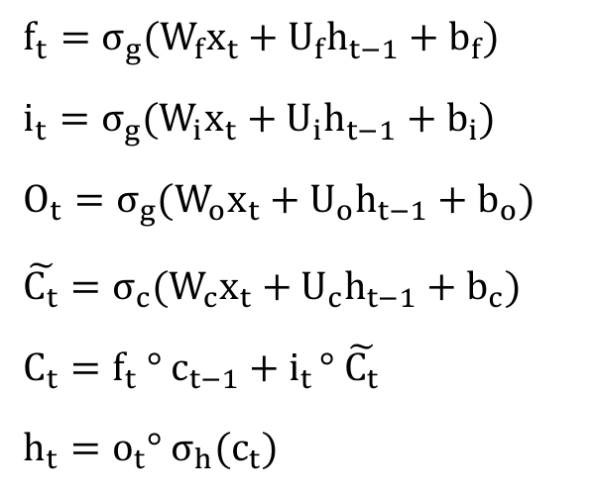
LSTM unit with forgetting gate is given below :

Input, output and forgetting gate composed the common LSTM unit. The device will record this value at any interval time, the information inside and outside the three gate control devices. In many applications, compared with sequence learning methods such as RNN and hidden Markov model, LSTM is relatively insensitive to interval length.

Model Training and Evaluation
The LSTM model is trained on the prepared training dataset with a batch size of 32 and 50 epoch. The training process involves adjusting the model's weights to minimize the loss function, thereby improving the accuracy of predictions . Model evaluation is conducted on the test dataset, where the model's predictions are compared against the actual closing prices. The root mean squared error (RMSE) is calculated to quantify the model's prediction accuracy . Lower RMSE values indicate better model performance, where n is the number of observations, yi is the actual value of the i-th observation, and yi is the predicted value of the i-th observation

Description of working principle
LSTMs work in a three-step process.
- The first step in LSTM is to decide which information to be omitted from the cell in that particular time step. It is decided with the help of a sigmoid function. It looks at the previous state (ht-1) and the current input xt and computes the function.
- There are two functions in the second layer. The first is the sigmoid function, and the second is the tanh function. The sigmoid function decides which values to let through (0 or 1). The tanh function gives the weightage to the values passed, deciding their level of importance from -1 to 1.
- The third step is to decide what will be the final output. First, you need to run a sigmoid layer which determines what parts of the cell state make it to the output. Then, you must put the cell state through the tanh function to push the values between -1 and 1 and multiply it by the output of the sigmoid gate.
With this basic understanding of LSTM, you can dive into the hands-on demonstration part of this tutorial regarding stock price prediction using machine learning.

ARIMA Model Architecture
Autoregression model (AR) is a linear and easy understanding method in forecasting technologies, as the model assumes that future price can be fully reflected by the past information. However, empirical investigation may not always show excellent results. Thus, a ARIMA (auto regressive integrated moving average) was introduced to forecasting field, which is a natural extension of the AR model. Generally, three parameters (P, D, q) form the ARIMA model. P represents for the number of lag length in the auto regressive terms; q is a parameter for the moving average terms while D is to ensure a stationary sequence. A standard formation of
ARIMA is shown as follows.
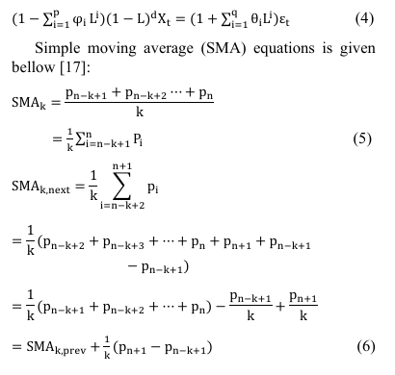

Assumptions
- Data Sufficiency for Training: The amount of historical data needed for more accurate prediction will be much higher. So, we are assuming the data we collect must be of more than 5 years.
- Closing Prices only: Since we are working on stock prices and in context of Nepal, there is no intraday, so we are taking only closing prices of the stock as data.
- While writing the code and during training and testing of our application, we will be taking data of only one stock and use it as the test subject.

Machine Learning Algorithms
Long Short-Term Memory (LSTM) algorithm is used in this project for predicting stock prices. Long Short-Term Memory (LSTM) networks are often considered better for stock market prediction compared to traditional models and other machine learning techniques because of following reasons:
- Ability to capture large sequential data and can learn long-term dependencies.
- It can handle Non-Linear and complex Patterns in the chart or prices
- It is more suited for time series data
- It has ability to learn from noise and volatility, since stock prices are often noisy and volatile

Data Collection
Since the API of official website of Nepal Stock Exchange (NEPSE) is not publicly available, all the necessary historical data will be collected from a website called NepseAlpha, a private company work in the field of stock market. We will be collected the OHLC(Open, High, Low, Closing) prices of the day for that stock of minimum 5 years.

Implementation Plan
Step 1: Python will be used as programming language, and VS Code and Google Colab is used as IDEs.
Step 2: Data are collected through Nepsealpha using Pandas
Step 3: Data will be manipulated and Pre processing on them will be accomplish through NumPy
Step 4: Model will be created in LSTM algorithm, using Keras from TensorFlow
Step 5: Data Training and Testing
Step 6: Data Validation, Prediction, and Evaluation
Step 7: Optimization and UI/UX design
Step 8: Documentation

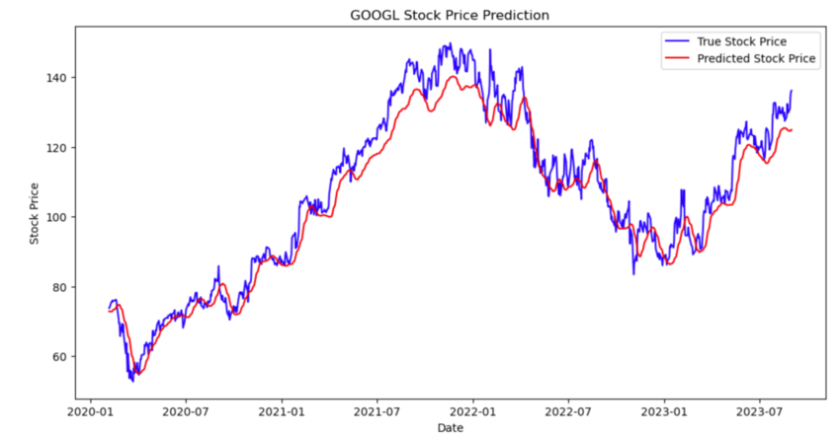
Chapter 4: Expected Output

Figure 4.1. Actual Prive vs Predicted Price

After completion of our Model, we can draw the actual price and our predicted price alongside the historical data of that stock or index, of predict the price of upcoming 30 days.

4.1.1 Performance Metrics
Mean Squared Error (MSE):
MSE measures the average of the squared differences between the predicted and actual values. It penalizes larger errors more severely than smaller ones, making it useful for detecting major deviations in stock price predictions.
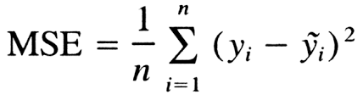
Formula:

Goal: Minimize the MSE to improve the accuracy of predictions.
Interpretation: Lower MSE indicates better model performance.

Chapter 7: CONCLUSION
In this study, we explored the application of Long Short-Term Memory (LSTM) networks for stock market analysis and prediction, focusing on four major stocks: Everest Bank Limited (EBL), Chilime Hydropower Company Limited (CHCL) and Standard Chartered Bank Limited (SCB). Our research demonstrated the potential of LSTM models in capturing complex patterns and trends in stock price movements, leading to reasonably accurate predictions of future prices. The findings of this study hold significant implications for both academia and the finance industry.
For investors and traders, the insights gained from our model could aid in making more informed decisions, potentially leading to improved investment strategies and portfolio management.
In conclusion, our study underscores the potential of LSTM networks in stock market analysis and prediction, offering valuable insights for both researchers and practitioners in the field of finance. As machine learning continues to evolve, its application in financial markets holds the promise of unlocking new opportunities for understanding and predicting stock price movements.

References

[1] | "Deshmukh, Yogita & Saratkar, Deepmala & Tiwari, Yash. (2019). Stock Market Prediction Using Machine Learning. IJARCCE. 8. 31-35. 10.17148/IJARCCE.2019.8107.".
[2] | "Polamuri, Dr & Srinivas, Kudipudi & Mohan, A.. (2020). A Survey on Stock Market Prediction Using Machine Learning Techniques. 10.1007/978-981-15-1420-3_101.".

References

[1] | "Deshmukh, Yogita & Saratkar, Deepmala & Tiwari, Yash. (2019). Stock Market Prediction Using Machine Learning. IJARCCE. 8. 31-35. 10.17148/IJARCCE.2019.8107.".
[2] | "Adebiyi, Ayodele & Adewumi, Aderemi & Ayo, Charles. (2014). Stock price prediction using the ARIMA model. Proceedings - UKSim-AMSS 16th International Conference on Computer Modelling and Simulation, UKSim 2014. 10.1109/UKSim.2014.67.".
[3] | "Heaton, J. B., Polson, N. G., and Witte, J. H. (2017) Deep learning for finance: deep portfolios. Appl. Stochastic Models Bus. Ind., 33: 3–12. doi: 10.1002/asmb.2209.".

